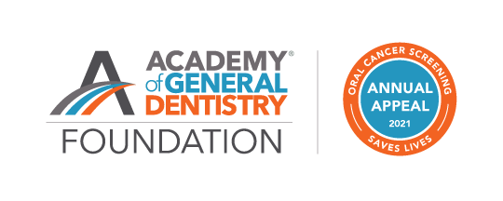

<date>

Dear <Prefix> <Lastname>,

As an AGD constituent, for nearly half a century, the AGD Foundation, the philanthropic arm of AGD, has recognized the critical role of general dentists in advancing the oral health of the public through charitable initiatives. In recent years, the Foundation has:

- Awarded more than $220,000 in grants to AGD constituents and other organizations to fund oral and oropharyngeal cancer awareness and early detection programs
- Hosted free oral cancer screening events throughout the United States, often providing services to individuals without regular access to dental care
- Created and promoted diagnostic continuing education courses, videos, and patient resources for AGD members and the greater dental community

Despite the toll of the COVID-19 pandemic, the AGD Foundation has continued to provide these quality programs and resources to decrease the incidence of oral and oropharyngeal cancer. The recent rise of HPV-related cancer is a reminder that our work is more critical than ever. We hope to continue to provide oral cancer awareness and screening programs along with free educational resources for AGD members and the greater dental community. We are now looking to you, as leading AGD constituent organizations, to help us achieve this goal. Please give a gift today.

Your donation to the AGD Foundation, at any level, will expand the number of dentists and patients we are able to impact. The Donor Recognition Levels attached show the impact your donation can have. We kindly ask that your organization consider giving a donation to the AGD Foundation today.

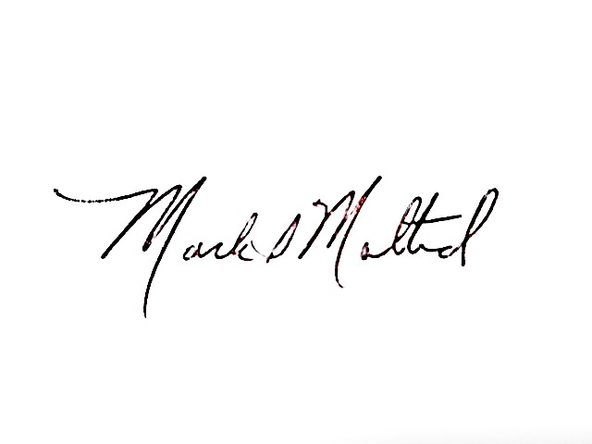
Please email or call us with any questions at agdf@adgcommunications.com; (518) 694-5545.
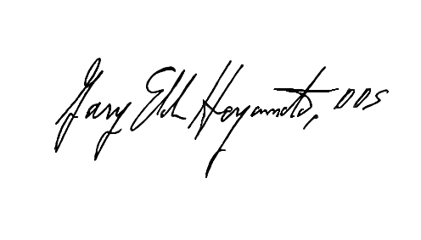
Sincerely,

Gary E. Heyamoto, DDS, MAGD Mark Malterud, DDS, MAGD
President, AGD Foundation Vice President, AGD Foundation

