CSV Roster
Submission Guide

In 2005 the AGD began requiring PACE-approved program providers to submit continuing education credits for all AGD members directly to the AGD by fax, mail or online within 30 days using a standardized form set forth by the AGD.

In 2016 it was announced that, effective Jan. 1, 2017, providers must use AGD’s online roster to submit CE hours earned by AGD members. Providers must be logged onto the AGD website to access the online roster.

Effective Sept. 1, 2019, AGD will only accept course rosters submitted electronically.

To improve efficiency, AGD is now also accepting rosters from continuing education (CE) providers in a comma-separated values (CSV) file format. Here is what you need to know.

CSV is a simple file format used to store data, such as a spreadsheet or database. Files in the CSV format can be imported to and exported from programs that store data in tables, such as Microsoft Excel or Apache OpenOffice Calc.

Reference the information below to learn how to submit CVS rosters of AGD members who attended your courses AGD.

Before uploading your CSV roster, keep in mind the following:

1. You must have the attendee’s AGD Member ID Number.
- All AGD members are assigned their own unique six-digit ID number. This number is required, as it is the key to matching the CE data to the proper record in the AGD database.
- If an attendee indicates they are an AGD member but did not provide their ID number, you can look it up by clicking the FIND AGD MEMBER ID NUMBER link.
- This field will only accept a six-digit number.
- Submitting alpha characters or more or less than six digits will generate an error message.
- Six-digit numbers that do not exist in the AGD database will also generate an error message.
- AGD recommends that you ask course attendees for their AGD ID number when they register for your course so that you have it on file before the course.
- Not all attendees will be AGD members. If an attendee is not an AGD member, you are not required to submit CE verification for them to AGD. You must provide CE verification directly to these attendees for their records.

2. If you allocate hours to different subject codes or delivery methods, you will need more than one line of data for each attendee.
- Each line of the spreadsheet/database can only have one subject code and one teaching method for the hours indicated.

Example:
If you offer a seven-hour lecture course on esthetics, and all seven of the hours should be allocated to esthetics, you will need to include only one line of data on your spreadsheet:
AGD Member ID Number | Course Date | Course Title | Number of Hours | AGD Subject Code | Delivery Method | Instructor Name | Location
303846 | 01/02/2019 | Test Course | 7 | 780 | Lecture | Alpha B. Test, DDS, MAGD, and Beta Test, MD, DMD | City, State

However, if this same course included two hours of hands-on activities and a discussion on restorative procedures, you may want to allocate some of the time to the operative/restorative subject area and the participation delivery method. The same seven-hour course may require four lines of information for each AGD member who attended:
AGD Member ID Number | Course Date | Course Title | Number of Hours | AGD Subject Code | Delivery Method | Instructor Name | Location
303846 | 01/02/2019 | Test Course | 1 | 780 | Participation | Alpha B. Test, DDS, MAGD, and Beta Test, MD, DMD | City, State
303846 | 01/02/2019 | Test Course | 1 | 250 | Participation | Alpha B. Test, DDS, MAGD, and Beta Test, MD, DMD | City, State
303846 | 01/02/2019 | Test Course | 2.5 | 780 | Lecture | Alpha B. Test, DDS, MAGD, and Beta Test, MD, DMD | City, State
303846 | 01/02/2019 | Test Course | 2.5 | 780 | Lecture | Alpha B. Test, DDS, MAGD, and Beta Test, MD, DMD | City, State

3. Enter the course date as mm/dd/yyyy.

4. The COURSE TITLE, INSTRUCTOR NAME and LOCATION fields will accept all alpha-numeric characters.
- Course Title: We recommend you include the full course title exactly as it was advertised and is printed on the attendee attendance verification forms. The field will accept up to 255 characters.
- Instructor Name: Whenever possible, we recommend the following format: FirstName, Middle Initial, LastName, Credential, Credential, Credential. The field will accept up to 50 characters.
- Location: Listing the city and state of where the training was held is sufficient. The field will accept up to 100 characters.

5. The number of hours can be expressed in whole or decimal numbers.
- Submitting a case fraction, such as ½, will generate an error message. Submit as .5 instead.

6. Only valid AGD Subject Codes will be accepted.
- Submitting an invalid number will generate an error message.
- Click on FIND AGD SUBJECT CODE to find the correct AGD subject codes for your courses.

7. LECTURE, PARTICIPATION or SELF (for Self-Instruction) are the only delivery methods that will be accepted.
- You must spell these out exactly. Entering anything else will generate an error message.

Once you have prepared your roster, make sure to save you file as a CSV file.
- If you are unsure of how to save a file in the CSV format, check the help tools on the product you are using, or use an internet search engine to find information regarding your software and CSV formatting.

SUBMITTING YOUR CSV ROSTER
1. Log onto www.agd.org using your provider ID # as your username and your unique password.

2. Click on the Menu.

3. From the menu click on the “+” next to Continuing Education and then the “+” next to PACE. Then click on PACE PROVIDER RESOURCES.

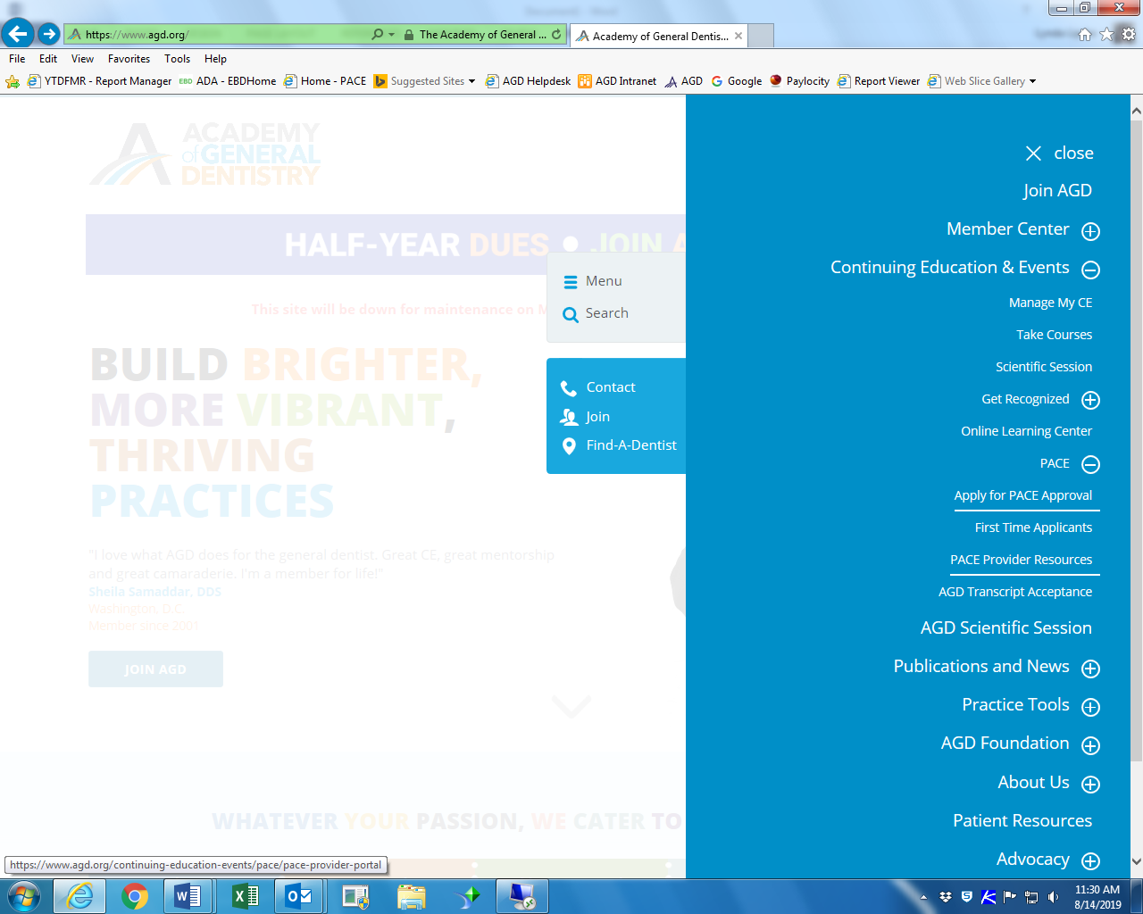
4. Click on CSV File Upload.

<NEED TO ADD SCREEN SHOT ONCE PAGE IS REVISED>

- Once on www.agd.org/roster-csv, click the CHOOSE FILE button.

- Select your file, and click on the CONTINUE button.

- The data will be sent to AGD, and any records with errors in them will be displayed.
- If you have errors:
- You can cancel the transaction, fix the file and resubmit, or
- You can continue. Records with errors will not be sent to AGD.

- Click CONTINUE.
- Once you hit CONTINUE, you will receive confirmation of the records that have been accepted by AGD.
- You will be sent a confirmation email and the roster will appear in your UPLOAD History after you refresh the page.
- You are also able to print/save the information to a PDF file by first clicking on the Printer Friendly link on the upper right corner of the list, then the printer icon ().

NOTE: Once a roster has been submitted, you are unable to make changes.
- If you left one or more members off the roster, please submit a new roster with the information that was left off the original roster.
- If incorrect information was submitted, please contact the AGD membership department at membership@agd.com and explain what changes are needed.

