**Introduction to Forensic Odontology**

**Speaker:** Dr. Grace Chung **Date:** October 16, 2024 from 6:30-8 pm PST

**Educational Method:** Lecture **Subject:** 145 **Credits:** 1.5 **Location:** Virtual **Audience:**General Dentists, Specialists, Hygienists, Dental Students, Residents

**Fees:** NV AGD Members: $10 Non-Member: $20 Student AGD Member: $0 Non-Member Student: $5

[**REGISTER HERE**](https://agdnevada.ticketspice.com/intro-to-forensic-odontology)

**Course Description:** This course will provide an overview of the facets of forensic dentistry. Attendees will learn how forensic odontology plays a role within the forensic science community. Attendees will be introduced to the three major components of forensic dentistry: human identification, age assessment, disaster victim identification and jurisprudence.

**Learning Objectives:**

1) Provide an overview of the basic components of forensic odontology.

2) Discuss human identification and age assessment techniques.

3) Review disaster victim identification.

4) Understand jurisprudence related to forensic odontology.

**Instructor Qualifications**: Dr. Kucharski is an Assistant Professor of Clinical Sciences at the University of Nevada, Las Vegas. After practicing in southern California, she moved to North Lake Tahoe, purchased a practice on the Lake. She is an avid skier, trail runner and golfer. Dr. Kucharski completed a fellowship at the University of Tennessee in Forensic Odontology and practiced under the Chief Odontologist at the Washoe County Medical Examiner's Office. Dr. Kucharski has been involved with access to dental care in remote areas such as Nepal, and Indonesia. She has trekked in Nepal to remote regions with health care teams to offer a variety of care. She has also volunteered on the USNS Mercy in East Timor, Indonesia. Additionally, Dr. Kucharski works with the Nevada State Board of Dental Examiners as a Preliminary Expert Screener.

***Requirements:*** *Access to a computer that can play sound, is required for participation the Nevada AGD live webinar. No special computer knowledge or equipment is required to participate; however, the webinar utilizes the Zoom platform. Specific instructions will be disseminated upon registration to assist with course access.*

***Cancellation Policy:*** *Cancellations by participant are permitted up to 7 days prior to the event subject to a cancellation fee of 50% of the course cost. Cancellations or failure to join will not be refunded. If NV AGD cancels the program, participant will be reimbursed the full tuition amount.*

AGD-Nevada

Nationally Approved PACE Program Provider for FAGD/MAGD credit.

Approval does not imply acceptance by

any regulatory authority or AGD endorsement.

4/1/2022 to 3/31/2026

Provider ID# 219314

c

[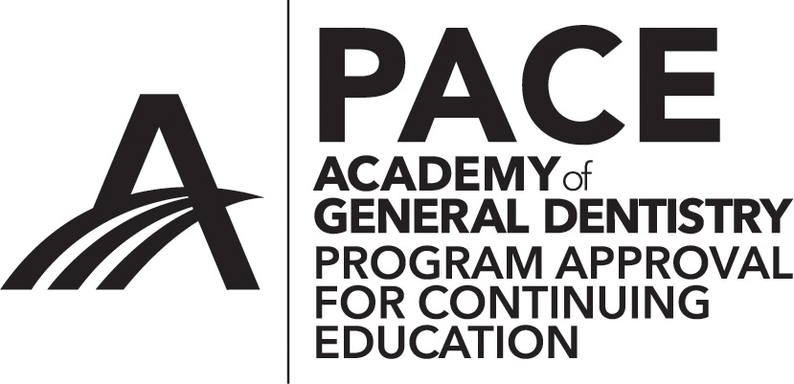](http://www.agd.org/images/logo/PACE/PACElogohires.tif)