**Peer Review or Board Complaint: What to Do Now!**

**Speaker:** Dr. Joseph Wineman **Date:** September 18, 2024 from 6:30-8 pm PST

**Educational Method:** Lecture **Subject:** 550 **Credits:** 1.5 **Location:** Virtual **Audience:**General Dentists, Specialists, Hygienists, Dental Students, Residents

**Fees:** NV AGD Members: $10 Non-Member: $20 Student AGD Member: $0 Non-Member Student: $5

[**REGISTER HERE**](https://agdnevada.ticketspice.com/surviving-a-board-complaint)

**Course Description:** This course will explain the procedures usually followed when a patient files a complaint with either the local Peer Review Committee or the State Dental Board and how the dentist should respond to each. The presentation will identify the four areas usually allowed under the Peer Review system, showcase the main reason for a patient complaint, and share with the attendees the possible outcomes that can occur from each scenario.

**Learning Objectives:**

1. Know the difference between a peer review complaint and a state dental board complaint.

2. Identify the times frames within which a dentist must respond to each type of complaint.

3. Name the four areas under which a patient can file a peer review complaint.

4. Explain the types of punishment that can be given to a dentist from either process.

5. Explain the most common cause for any type of patient complaint.

**Instructor Qualifications**: Joseph A. Wineman DMD, ABGD is a Comprehensive Dentist who retired in 2002 as a COLONEL in the US ARMY Dental Corps after 26.5 years on active duty. A 1981 graduate of the University of Pittsburgh School of Dental Medicine, Dr. Wineman has been practicing dentistry for 43 years. Even after all the time living around the globe, he remains a diehard Pittsburgh Steeler fan. Dr. Wineman deployed in support of Operation Desert Shield/Desert Storm providing emergency dental care to NATO soldiers and Enemy Prisoners of War and earned Bronze Star. Married for 46 years to his college sweetheart, he is the father of 3 grown children and 8 grandchildren. In his spare time, he enjoys floating in the backyard pool, working out weekly with his personal trainer, recovering with a 10 minute cold plunge, donating his talents to assist others less fortunate with the Tzu Chi Foundation and the Tonopah Dental Center, and is a FAA licensed Part 107 UAS/Drone Pilot. Dr. Wineman has served as SNDS Peer Review Chairman (2010-2016), President of the SNDS (2017-2019) President of the Nevada Dental Association (2023-2024) and is currently the President of the Nevada Academy of General Dentistry. In his free time, he leads a Spear Study Club in Henderson, Nevada.

***Requirements:*** *Access to a computer that can play sound, is required for participation the Nevada AGD live webinar. No special computer knowledge or equipment is required to participate; however, the webinar utilizes the Zoom platform. Specific instructions will be disseminated upon registration to assist with course access.*

***Cancellation Policy:*** *Cancellations by participant are permitted up to 7 days prior to the event subject to a cancellation fee of 50% of the course cost. Cancellations or failure to join will not be refunded. If NV AGD cancels the program, participant will be reimbursed the full tuition amount.*

AGD-Nevada

Nationally Approved PACE Program Provider for FAGD/MAGD credit.

Approval does not imply acceptance by

any regulatory authority or AGD endorsement.

4/1/2022 to 3/31/2026

Provider ID# 219314

c

[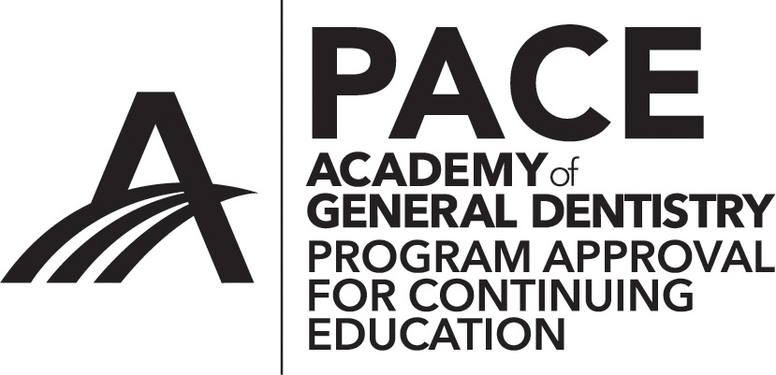](http://www.agd.org/images/logo/PACE/PACElogohires.tif)