March 24, 2021

The Honorable Vivek Murthy, M.D.
Office of the Surgeon General
U.S. Department of Health & Human Services
200 Independence Avenue, S.W.
Washington, D.C. 20201

Dear Dr. Murthy,

On behalf of the Academy of General Dentistry’s (AGD) 40,000 members, we would like to congratulate you on your recent confirmation as the 21st Surgeon General of the United States. In light of your confirmation, the AGD looks forward to working with you and your staff to improve the status of our nation’s oral health.

The AGD’s mission is to promote the public’s oral health, serve the needs and represent the interests of general dentists, and foster continued proficiency of general dentists through quality continuing dental education to better serve those we treat. Our members are the gatekeepers of their patients’ oral health and remain at the heart of the ongoing discussion to expand access to oral health care.

The AGD recognizes the numerous health care challenges currently confronting our country. Yet, as you are undoubtedly aware, underutilization of existing oral health care systems continues to persist, a problem that current oral health programs only partially address. As the Administration and Congress move forward in their deliberations regarding our nation’s health care delivery system and responding to the COVID-19 pandemic, we urge you not to lose sight of the vital role oral health plays in the overall health of both children and adults. Educating the public about the importance of maintaining good oral health should be a foundational part of national health policy.

The AGD stands ready to work together on implementing these ideas and serving as a valuable resource to you and your staff. Should you have any questions about the AGD in general, please do not hesitate to contact Daniel J. Buksa, JD, Associate Executive Director, Public Affairs, by phone at (312) 440-4328 or via email at daniel.buksa@agd.org.

Again, please accept our congratulations and best wishes for your success.

Sincerely,
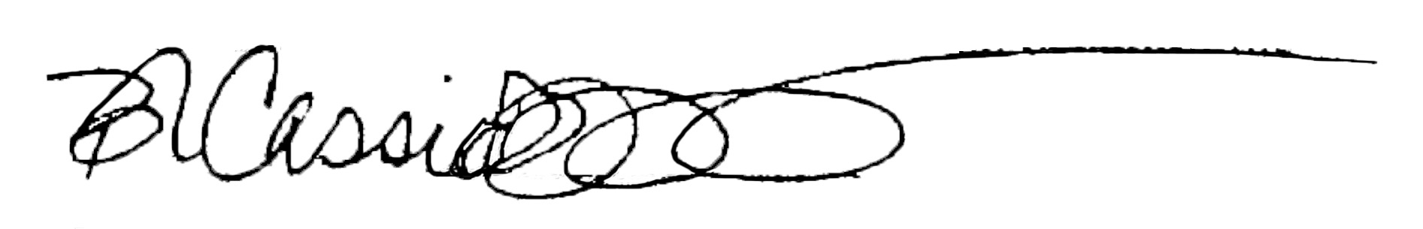

Bruce Cassis, D.D.S., MAGD
President
Academy of General Dentistry

Myron (Mike) Bromberg, D.D.S.
Congressional Liaison
Academy of General Dentistry

cc: Timothy L. Ricks, D.M.D., MPH, FICD
Rear Admiral (RADM), Assistant Surgeon General

