Instructions/FAQ’s for Using the New Learning Platform for Self-Instruction

How would I access the AGD’s online Self-Instruction program?
- Go to www.agd.org
- Go to Menu and click on Continuing Education Events.
- Click on Self-Instruction. This will redirect you to the Self-Instruction page on the AGD website.
- Click on the Access the Self-Instruction button.
- Login with your AGD username and password.
- You are now at the AGD Online Learning Center home page.
- Select “Go to Your Learning Center” or “Browse Catalog” to continue.
- Save this site as one of your favorites.
- For questions regarding Self-Instruction, General Dentistry or OnDemand Webinars, please contact topclass@agd.org.

How can I access Self-Instruction Exercise?
In the Browse Catalog, under the Browse by Category section, scroll down to select either General Dentistry or AGD Impact. Once you have selected, the available exercises will appear on the right side of the screen. Click the Sort By function ( )and select Title. Scroll down to select the exercise you wish to purchase.

Can I still purchase Self-Instruction bundled exercises?
Yes, listed in the General Dentistry section, you will have the ability to purchase 3-, 6-, or 12-exercise bundles at a discounted rate. In the Impact section, you will have the ability to purchase 2- or 4-exercise bundles. Again, Select the Sort By Title Function ( ) and the bundles will appear at the top of the sorted list.

Once you have purchased a GD or Impact bundle, select an exercise to complete. The system will automatically redirect you to your shopping cart. Click on the View Cart button at the top right of the screen.

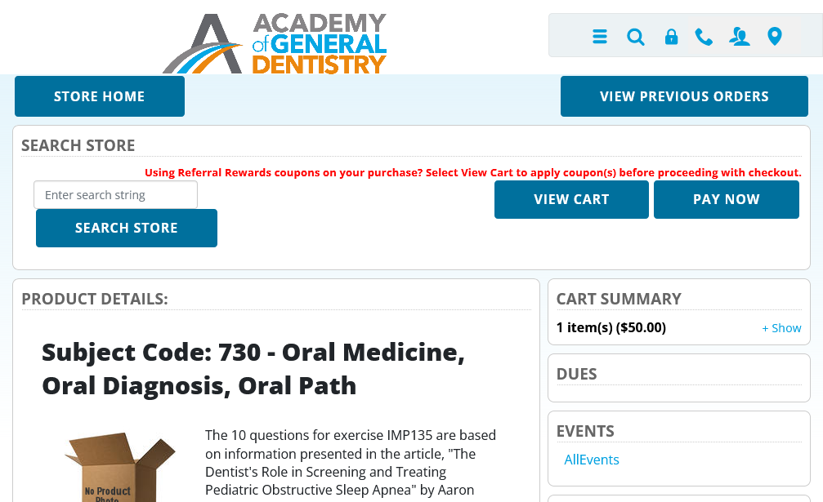

Once you have clicked on the View Cart button, your coupon code will automatically be synced to the exercise and zero out your balance owed for the exercise.

If you have multiple bundles purchased, you can select which bundle you would like to have applied toward the exercise you wish to obtain. Simply click on the View Cart button and a pop-up window will appear. Select the bundle you would like to use to have the coupon code synced to the exercise.

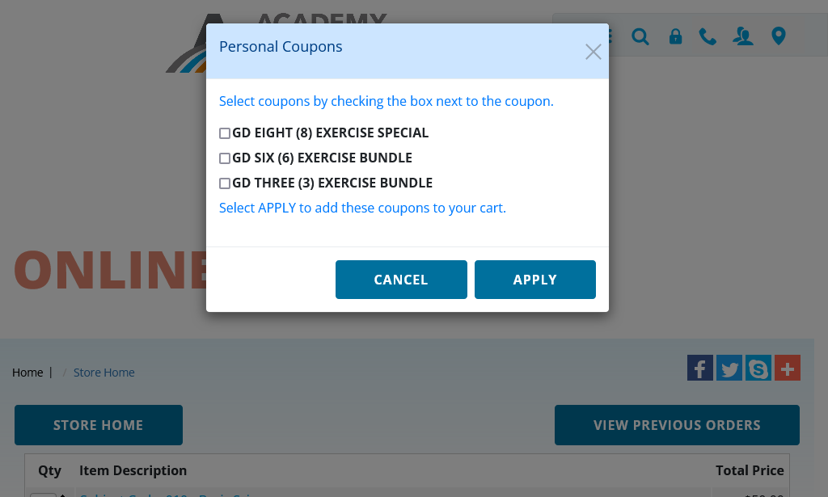

After you apply the coupon, you press the "Place Order" button. This will show you an invoice. Then you press the "Place Order" button again to actually purchase the course. Please note that the process may take up to 60 minutes to occur.
Once you have completed the process, you will need to go back to the Self-Instruction website page and click the Access Self-Instruction button (at the bottom of the page) or click the Online Learning Center (on the right side of the screen) to re-access the Self-Instruction program. Click on “Go to My Learning Center” to find the exercise you purchased (under the current tab) or go to “Browse Catalog” and enter the exercise name (GDXXX or IMPXXX) in the Search Catalog box at the top of the screen. You should now have a “Launch” button to start the exercise you selected.

Are my bundled exercise purchases transferrable across Self-Instruction programs?
No, bundles purchases can only be used for the within the program you purchased them. You will not be able to use General Dentistry bundled purchases within Impact or vice-versa.

How long do I have to use my bundled exercises?
Bundled exercise purchases are available for one year from the time of purchase then they will expire. Extensions will not be issued for expired bundles.

Will I still be able to use my previously purchased bundles?
Yes, if you purchased bundles within the Gauge system but did not complete them, you will be given credit for those purchases.

When will I have access to my previously purchased bundles?
The AGD is currently working to provide members with credit from their previously purchased bundles. Credit will be based on the number of exercises that were not used within the bundle. Members will be sent an email with information on their bundle credit and how to redeem this credit.

What is the passing score for OnDemand and Self-Instruction online activities?
When taking OnDemand and/or Self-Instruction online activities, the participant must pass the quiz with a score of at least 80% to receive the CE credit. Participants will get 3 attempts to pass the quiz.

How to obtain a copy of my CE Verification Certificate?
Go to your Learning Center, then click on the Completed tab. There you will be able to view, download, and print your verification certificates for all completed courses. For question, please contact, TopClass@agd.org.

Who to reach out to with issues logging into online learning center?
If the participant is within TopClass, questions would be directed to topclass@agd.org. When the AGD Team (Membership or Education), receives a question directly from a participant or member about logging into the AGD Online Learning Center, the Team can reach out to IT through a helpdesk request for assistance.

How long will it take for my course to show up on my AGD transcript?
Credits will be on the transcript within 24 hours of completion and upon passing the quiz.
When will the link for the access to my Self-Instruction exercises be emailed?
You will receive a link to the Self-Instruction exercise within 15 minutes.

Will the AGD record my CE from successfully completing my Self-Instruction exercise?
Yes, the CE will be recorded on your transcript generally within 24-48 hours.

What method will I get, Self-Instruction or Lecture?
The CE Verification Certificate will have the delivery method as Self-Instruction

